User’s Manual

1. Controls

* Make sure caps lock is off
* The cursor on the game grid or menu is represented by green rectangle
* Press W to move the cursor up
* Press S to move the cursor down
* Press A to move the cursor left
* Press D to move the cursor right
* Press enter to select the card or option
* Avoid pressing enter when the program is transitioning (“level up” or “game over” is displayed) as it will cause you to inadvertently select the option in the next grid or menu. In the “game over” case, pressing enter during the delay period will skip the menu because the program still reads keystrokes when it is sleeping.

1. Clues

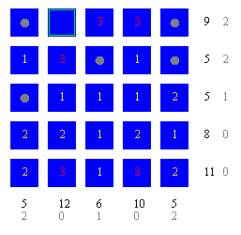

Each cell of the grid is a card that can contain a value of 1, 2, 3 or a bomb (worth 0, represented by a gray dot)

Black numbers show the sum of card values in the row or column

Gray numbers show the number of bombs in the row or column

1. Basics of the game

* The main objective of the game is to flip all cards except for bombs
* The first level is played on a 5x5 grid of cards
* When all cards except bombs in a row or column is flipped, a point is scored
* This point is multiplied by the level (2 points for level 2, 3 points for level 3, etc.)
* There are 6 lives at the beginning of the game. When a bomb is flipped, a life is deducted
* When the entire grid is cleared, the game advances to the next level
* Each increase in level will add a row and column to the grid, capped at 9x9
* The game ends when there are no more lives